Update on A8L Horch shooting requirements

Date: Oct.14th
Model: A8L Horch
Footage: A8L Horch reveal and static shots
Location: shooting studio

Date: Oct.15th
Speaker: Marc Lichte
Models: A8L Horch & Horch 853A
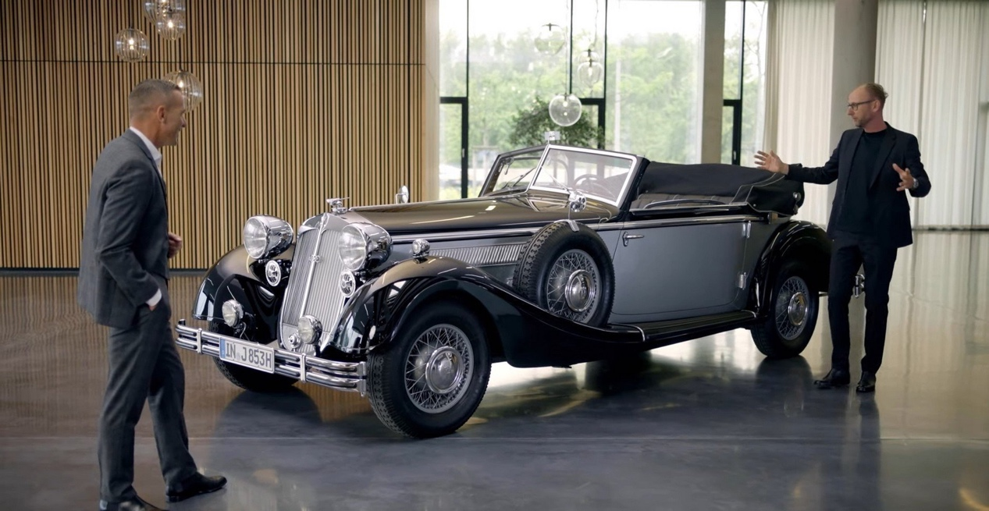
Location: The scene is as follow

Date: Oct.16th（TBD）
Model: A8L Horch
Footage: A8L Horch driving shots
Location: TBD

Note:
The footage of Hildegard Wortmann shooted by Audi AG

